Devon Air Ambulance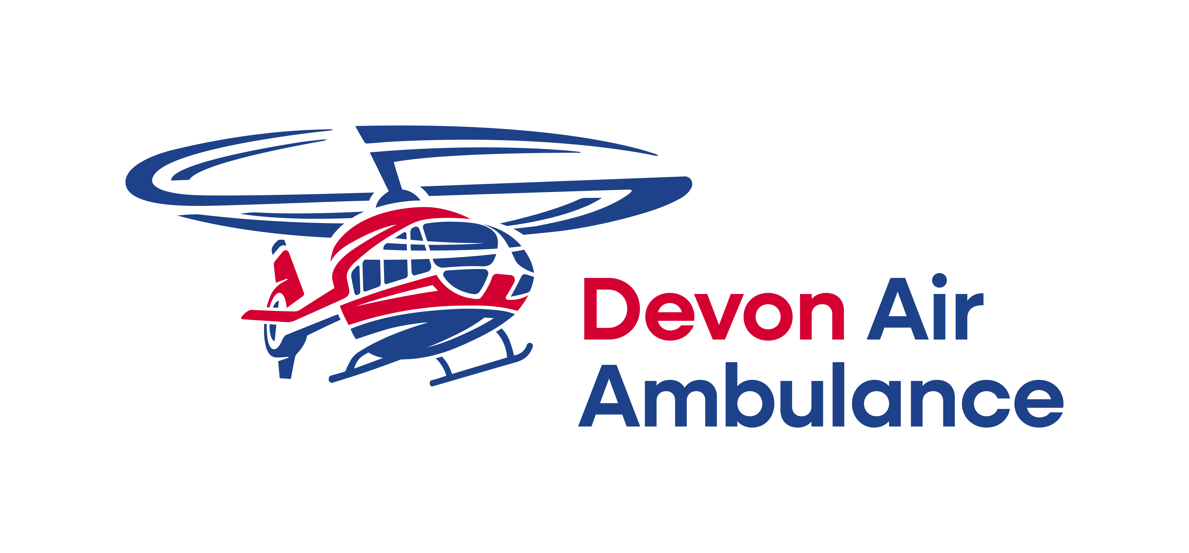  
Social Media Community Guidelines

Social media is an important way for Devon Air Ambulance to connect with our supporters, share our expertise and tell the real stories of the people across Devon and beyond who have needed our help.

It is therefore very important to us that our social media channels are an inclusive, safe place for everybody. To ensure that this is possible, we request that you adhere to the following guidelines when interacting on our social media channels.

These guidelines apply to our Devon Air Ambulance and ShopDAAT social media channels (such as Facebook, X, Instagram, LinkedIn, YouTube and TikTok). In addition to these guidelines, you should also adhere to the terms and community guidelines set by the social platforms themselves.

1. Don’t share your personal information

Devon Air Ambulance’s social media channels are visible to the public. Any content posted on these channels can be seen by everyone. Please do not share any personal or confidential information when interacting with our social media channels, and only post content that is appropriate to be in the public domain.

2. Stay on topic

We encourage discussion on our social channels – it helps us connect with you, our supporters. Please make sure your comments relate to the topic of discussion, and refrain from posting content which may be considered:

* Spam content
* Third-party marketing or promotional materials
* Off-topic comments

3. Respect Others

Please respect and be kind to others. Devon Air Ambulance does not tolerate any form of harassment or abuse. We will not tolerate comments which:

* Are abusive or threatening towards ourselves or others
* Are hateful or discriminatory based on race, sex, religion, nationality, disability, sexual orientation, gender reassignment, age or other protected characteristics
* Contain profanities or content of an obscene or distressing nature
* Are sexually explicit or pornographic
* May be considered fraudulent, deceptive, misleading or unlawful
* Contain any defamatory remarks
* Attempt to solicit personal or sensitive information from others

# 4. Only share content that you own

Please only share content that you own, or content that you have received full permission from the content owner to share. Where we suspect any content infringes copyright regulations, or intellectual property rights, we will remove it from our platforms.

**OUR MODERATION POLICY**

# Deleting Posts and Blocking Users

Comments or posts which do not meet these guidelines will be removed from our social media channels. We reserve the right to block or ban users who violate any of the guidelines from our channels at our discretion.

# Moderation Hours

Devon Air Ambulance’s social channels are monitored regularly throughout the day, with reduced hours on weekends and bank holidays. During busy periods it may take a few hours for us to respond to comments, or to remove comments which violate these guidelines.

Reporting Concerns

If you see a comment on our social channels that you believe violates our guidelines, or if you are messaged by a member of the community in a way that violates these guidelines, you can report it to us by emailing comms@daat.org.

# Disclaimer

Devon Air Ambulance is not responsible for third party websites (such as Facebook) or content that may be linked to from our social channels. Because our channels are public and anyone can participate, we cannot be responsible for any views that are expressed which are not our own.

Regretfully, admins of our social media pages cannot accept friend requests.